How AI differs from actual procedures from Microsoft.
1. 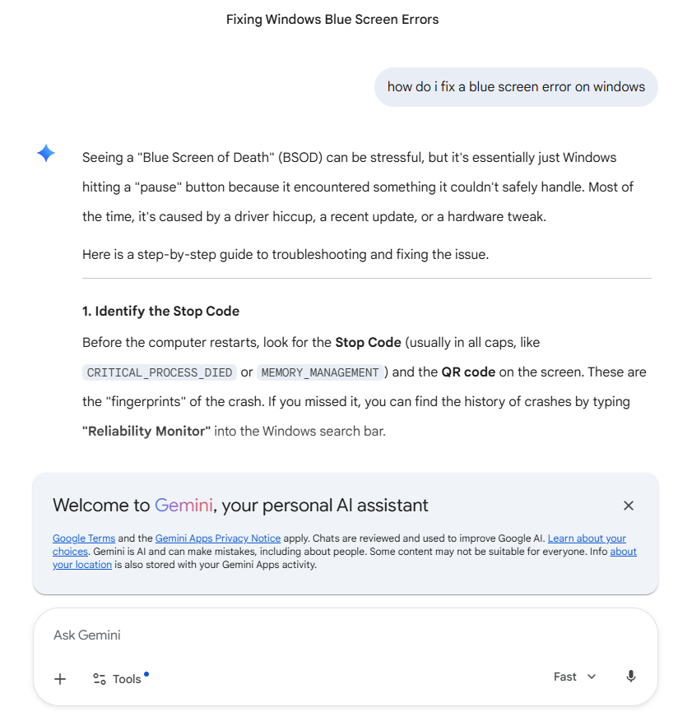
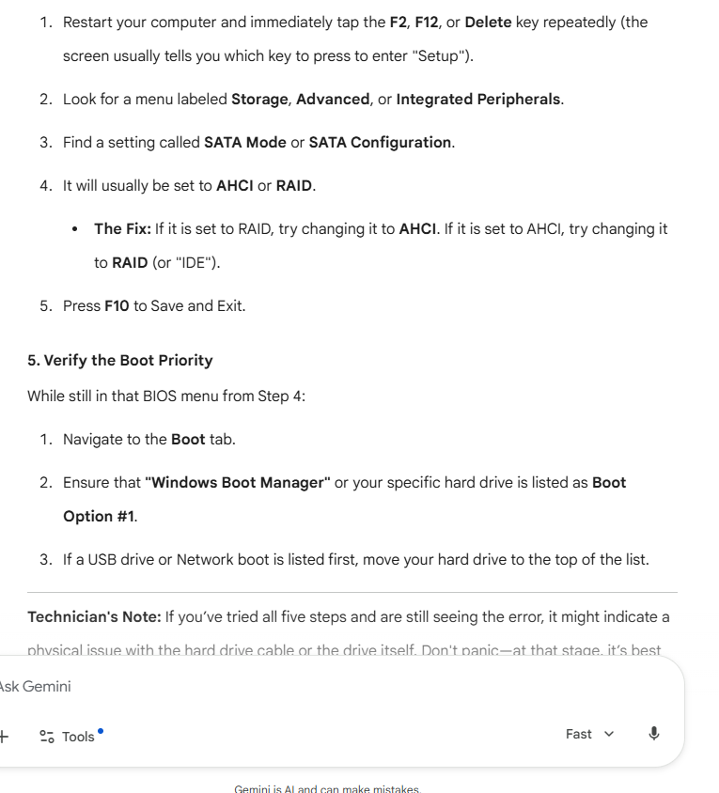
This response is quite helpful as most blue screens of death do create a code. A confusing part is the reliability monitor is not exactly word for word when you search it in the search bar its “view reliability history” which takes you to subsections that take you to reliability monitor under the control panel window. This differs a lot from the windows troubleshooting I checked it on google and it went into great detail about how to type in commands on the command line to check the pathways to ensure the boot sequence is correct it achieves the same goal as going through the GUI but is a lot more technical.

